Upgrade Guide

Topology is :
PC connects to mgmt port of OLT.

ftp server config
1.Open the wftp software(ftp server), and make sure the subnet of server IP is the same as OLT.
Such as, server IP is 192.168.5.133, OLT IP is 192.168.5.52 (or server IP is 192.168.120.11, OLT IP (default IP) is 192.168.120.100)

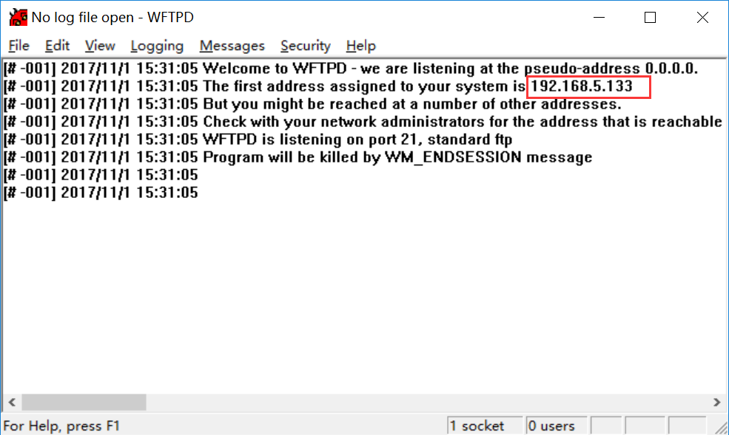

2.Click SecurityUser/rights….
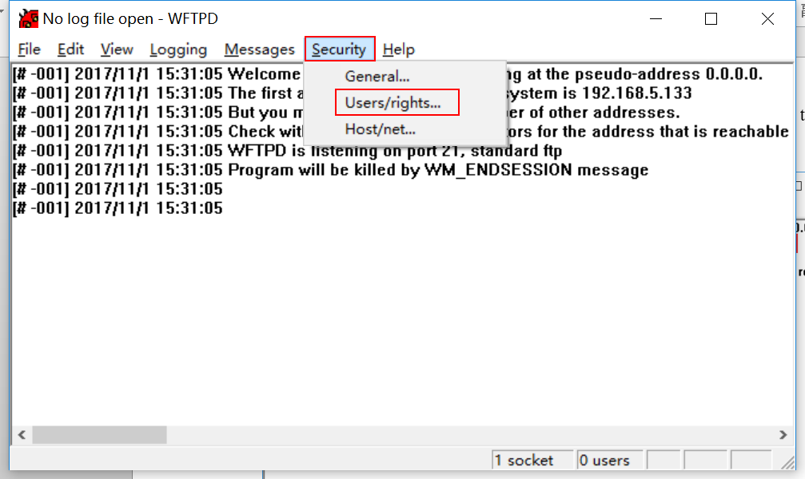

3.Click New User… to set a username and password
What’s more, we can click the Change Pass… to change the password, such as username :admin ,password: admin.
Click Browser to select the firmware path. After that, click done to finish the ftp server config.
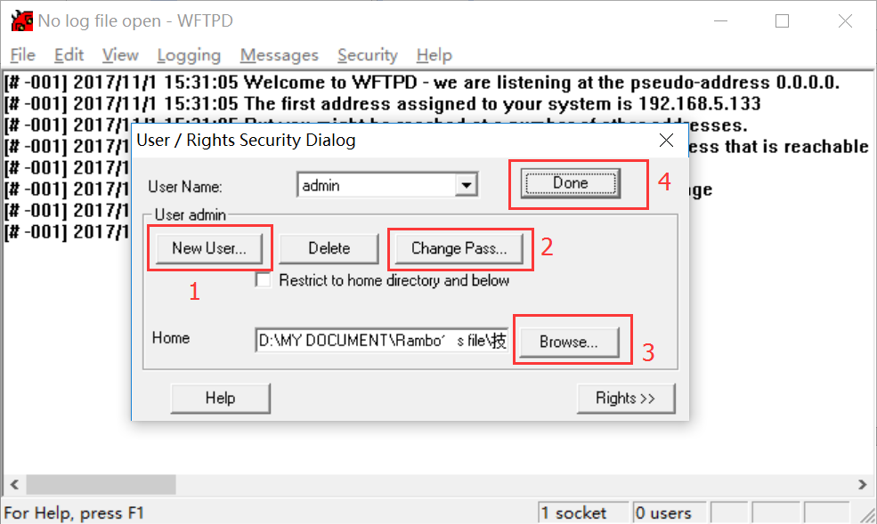

2.Upgrade the OLT
Login the 2 pon port OLT by CLI.
Type command:
upgrade 192.168.5.133 admin admin <firmware-name>
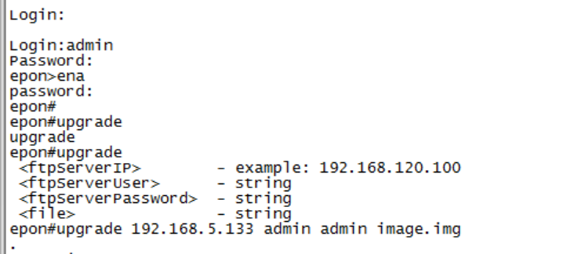

The way to upgrade the 16 pon ports OLT or 8 pon port GPON OLT
